**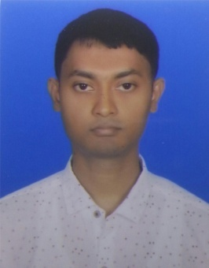CURRICULUM VITAE**

**Sultan Mahamud**

B.sc Engineer (Medical physics and biomedical Engineering)

Contact No: 01611475991

E-mail: [sultanmahamud322@gmail.com](mailto:sultanmahamud322@gmail.com)

**CAREER OBJECTIVE**

To be able to work as Biomedical Engineer in a world class organization where my demonstrated skills in biomedical electronic systems and other technical equipments will be greatly challenged in achieving the company’s goals and objectives in developing solutions to health problems.

**EDUCATIONAL QUALIFICATION**

**Bachelor of Science in Biomedical Engineering (B.sc in BME)**

University : Gono Bishwabidyalay

Subject : Medical physics and biomedical Engineering

Result : Waiting for result( published this month)

Passing Year : 2020

**Higher Secondary School Certificate: (H.S.C)**

Collage : Savar Laboratory Collage

Group : Science

Result : CGPA 3.20 Out of 5.00

Passing Year : 2014

Board : Dhaka

**Secondary School Certificate: (S.S.C)**

School : Sristy Academic School Tangail

Group : Science

Result : GPA 3.81 Out of 5.00

Passing Year : 2011

Board : Dhaka

**EXTRA CURRICULAR ACTIVITIES**

Programming Language : Basic Javascript, php

Fontend Developer : Html5,Css3,jquerry,Bootstrap 4.0,Sass,flex-box,Git & Github

Software : Wordpress.org, Arduino IDE, Proteus

Microsoft office package : MS Word, MS Excel,MS PowerPoint

Work Portfolio Link : [https://themeforest.net/user/sm-theme`](https://themeforest.net/user/sm-theme%60)

**PERSONAL INFORMATION**

Full name : Sultan Mahamud

Father’s Name : Eng:Abdul hye Sikder

Mother’s Name : Feroza hye

Date of Birth : 03/08/1996

Blood Group : O+

Marital Status : Unmarried

National ID NO : 4208038036

Religion : Islam

Present Address : B-90 Imandipur Savar Dhaka

Permanent Address :Vill-Maitkumra, P.O-Shekhor, P.S-Boalmari, Dist-Faridpur

**LANGUAGE PROFICIENCY**

* Bengali Language : Mother Tongue.
* English Language : Reading Writing & Speaking Excellent.

**PERSONAL SKILLS & COMPETENCIES**

* Hard working under stress worthy environment
* Willing to accept responsibility & perform accordingly
* Open minded in adapting to new & challenging situation
* Ability to work in teams & maintain effective communication
* Good interpersonal skill in group-based tasks

**INTEREST & ACTIVITIES**

* Technology related working, software based related working, Internet related working, program related working, web Application related working

**DECLARATION**

I do hereby that all information presented have are true to my knowledge, if require a where applicable this documents can be supported by appropriate authentic certificates/papers.

Signature

Screenshot_1.png

DATE :28/03/2020